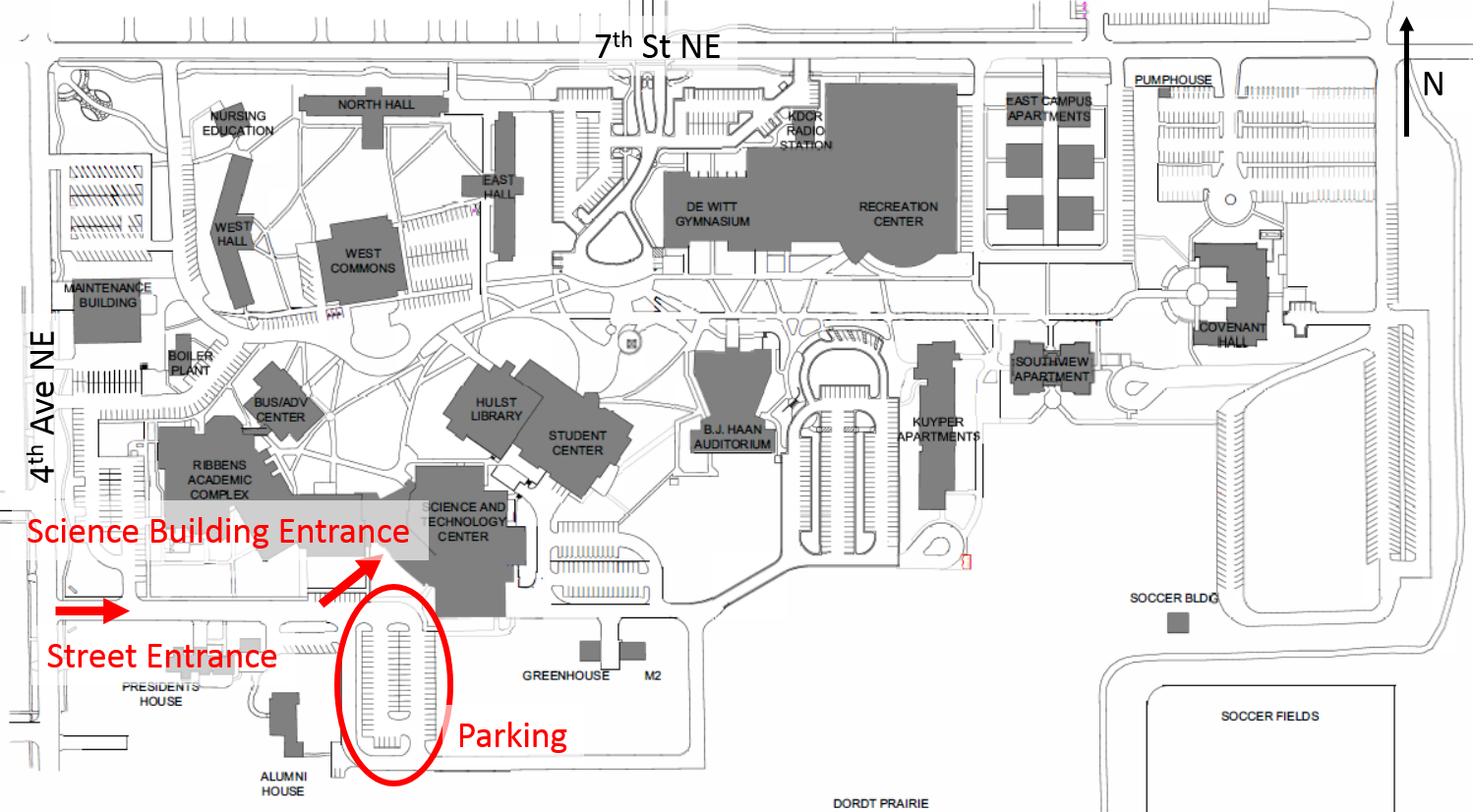

The campus is a few blocks east of Main Avenue (highway US-75) towards the north end of town. The top of the map is 7th St NE, which intersects Main at a stop light with Hardee's at the corner. For lodging there is an Econo Lodge and Holiday Inn Express in Sioux Center.

